ish¿u ysñlï weúßKs $ All Rights Reserved

St. Peter's College

St. Peter's College

St. Peter's College

புனித பேதுரு கல்லூரி

புனித பேதுரு கல்லூரி

புனித பேதுரு கல்லூரி

புனித பேதுரு கல்லூரி

புனித பேதுரு கல்லூரி

புனித பேதுரு கல்லூரி

புனித பேதுரு கல்லூரி

புனித பேதுரு கல்லூரி

Ydka; mS;r úÿy,

Ydka; mS;r úÿy,

Ydka; mS;r úÿy,

Ydka; mS;r úÿy,

Ydka; mS;r úÿy,

Ydka; mS;r úÿy,

Ydka; mS;r úÿy,

Ydka; mS;r úÿy,

Ydka; mS;r úÿy,

Ydka; mS;r úÿy,

St. Peter's College

St. Peter's College

St. Peter's College

St. Peter's College

St. Peter's College

St. Peter's College

St. Peter's College

St. Peter's College

St. Peter's College

St. Peter's College

புனித பேதுரு கல்லூரி

புனித பேதுரு கல்லூரி

புனித பேதுரு கல்லூரி

புனித பேதுரு கல்லூரி

புனித பேதுரு கல்லூரி

புனித பேதுரு கல்லூரி

புனித பேதுரு கல்லூரி

புனித பேதுரு கல்லூரி

Ydka; mS;r úÿy,

Ydka; mS;r úÿy,

Ydka; mS;r úÿy,

Ydka; mS;r úÿy,

Ydka; mS;r úÿy,

Ydka; mS;r úÿy,

Ydka; mS;r úÿy,

Ydka; mS;r úÿy,

Ydka; mS;r úÿy,

Ydka; mS;r úÿy,

St. Peter's College

St. Peter's College

St. Peter's College

St. Peter's College

St. Peter's College

St. Peter's College

St. Peter's College

41

**I,II**

**wmrÈ. ix.S;h**

**Western Music**

**meh 02**

**Two Hours**

**07 fY%aKsh – m<uq jdr we.hsu - 2024**

***Grade 07 – First Term Examination - 2024***

Ydka; mS;r úÿy, - fld<U 04

புனித பேதுரு கல்லூரி, கொழும்பு 4

***St. Peter's College - Colombo 04***

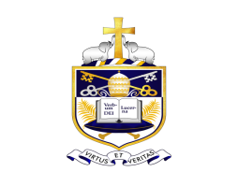

Name: ''''''''''''''''''''''''''''''''''''''''''''''''''''''''''''''''''''''''''''''''''''''' Class: '''''''''''''''''''' No: ''''''''''''''''''

**Part - I**

* **Underline the most suitable answer.**

01. Which of the following note is correctly written?

|  |  |  |  |
| --- | --- | --- | --- |
|  |  |  |  |
|  |  |  |  |
|  |  |  |  |
|  |  |  |  |

02. 4th space of the bass clef is,

i. G ii. E iii. A iv. C

03. Ramzan is a ___________ religious function.

i. Buddhist ii. Christian iii. Hindu iv. Islam

04. The correct way to writing the C major scale descending in bass clef as crotchets is,

|  |
| --- |
|  |
|  |
|  |
|  |

|  |
| --- |
|  |
|  |
|  |
|  |

|  |
| --- |
|  |
|  |
|  |
|  |

|  |
| --- |
|  |
|  |
|  |
|  |

05. Underline the word which is hidden with notes,

|  |
| --- |
|  |
|  |
|  |
|  |

i. CABAGE ii. CABGEA

iii. CABBAGE iv. CBAGEE

06. Which of the following is not a round,

i. Three bird mice ii. Bimbo iii. Softly sings the donkey iv. Row, row

07. Which of these instruments can be seen in Hindu music?

i. Organ , Violin ii. Mrudangam , Nathaswaram

iii. Geta bera , Yak bera iv. Daula , Thammattama

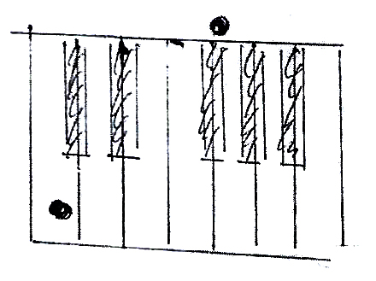08. The notes given on the keyboard are,

|  |  |  |  |
| --- | --- | --- | --- |
|  |  |  |  |
|  |  |  |  |
|  |  |  |  |
|  |  |  |  |

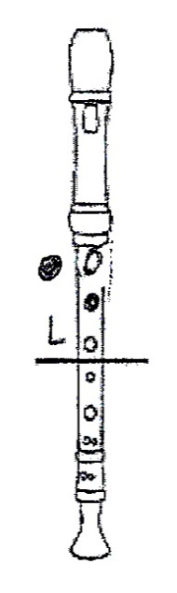09. The given note is,

i. B ii. A iii. C iv. G

10. What indicates the silence in music?

i. Notes ii. Clef iii. Stave iv. Rests

11. From which line does the treble clef start?

i. 2nd line ii. 4th line iii. 3rd line iv. 1st line

12. The time signature for 3 crotchet beats in a bar is,

i. ${4 \atop 3}$ ii. iii. iv.

13. The sign that raises a note by one semitone is,

i. # ii. iii. iv.

14. The letter name of this note is,

|  |
| --- |
|  |
|  |
|  |
|  |

i. F flat ii. E flat

iii. D flat iv. C flat

15. Which of the following is a precussion instrument?

i. Trumpet ii. Timpani iii. Trombone iv. Tuba

* **Write the correct answer.**

16. A semitone above B -

17. A semitone below G -

18. A semitone above D sharp -

19. A tone above A -

20. A tone below E -

**(1 $×$ 20=20 Marks)**

**Part - II**

* **Compulsory question.**

01. Observe the given music and answer the questions.

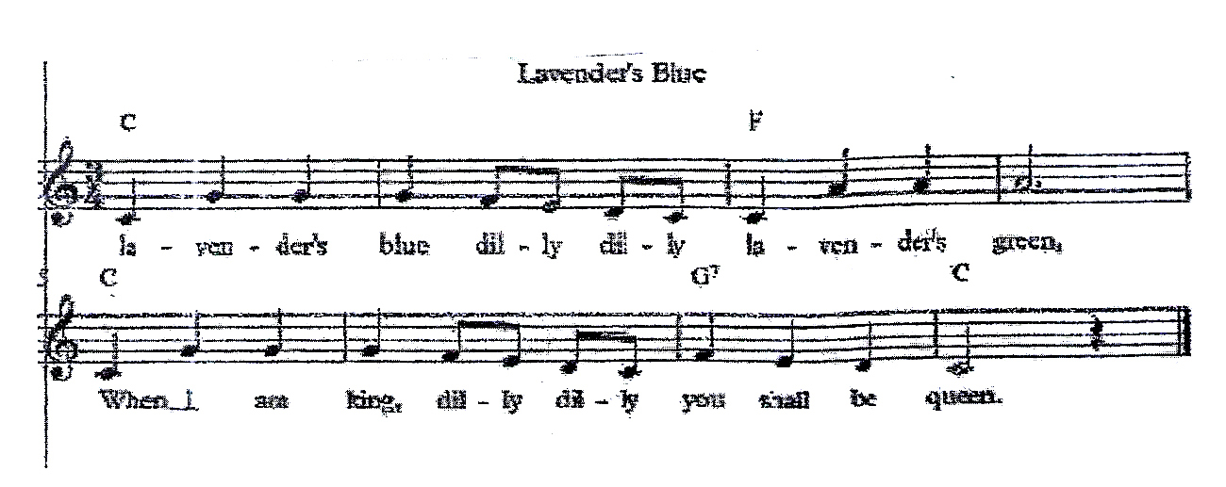

1. What is the name of the above piece?

2. In which clef is this written?

3. What is the time signature?

4. Explain the time signature.

5. How many bars are there in the music?

6. Circle the longest note.

7. What is the rest written in the last bar?

8. How many quavers are there in the melody?

9. Write the letter names of the following note.

|  |
| --- |
|  |
|  |
|  |
|  |

**(10 Marks)**

* Answer only two questions.

02. 1. Name the following notes.

|  |  |  |  |  |
| --- | --- | --- | --- | --- |
|  |  |  |  |  |
|  |  |  |  |  |
|  |  |  |  |  |
|  |  |  |  |  |

2. Name the two notes and state whether the distance between the given two notes is tone or semitone.

|  |  |  |
| --- | --- | --- |
|  |  |  |
|  |  |  |
|  |  |  |
|  |  |  |

Name ________________________________________________________

Tone or

Semitone ________________________________________________________

3. Draw the keyboard and name the white keys.

**(10 Marks)**

03. 1. Write these notes as crotchets.

|  |  |  |  |  |
| --- | --- | --- | --- | --- |
|  |  |  |  |  |
|  |  |  |  |  |
|  |  |  |  |  |
|  |  |  |  |  |

G above the

stave

D sharp

on a line

C flat in

a space

Middle C

A sharp

In a space

2. Put the correct clef and accidental to make the given name correct.

|  |  |  |  |  |
| --- | --- | --- | --- | --- |
|  |  |  |  |  |
|  |  |  |  |  |
|  |  |  |  |  |
|  |  |  |  |  |

E flat

B sharp

C natural

A flat

D sharp

**(10 Marks)**

04. 1. Add bar lines according to the time signature.

|  |  |
| --- | --- |
|  |  |
|  |  |
|  |  |
|  |  |

2. In each blank bar write a note equal in value to the given rest.

3. Name 4 sections of the orchestra and write 2 instruments which belong to each section.

1 ${1 \atop 2}$

___________________

2 ${1 \atop 2}$

___________________

3 ${1 \atop 2}$

___________________

4 ${1 \atop 2}$

___________________

**(10 Marks)**